AI-AUGMENTED BACKEND DEVELOPMENT
AI BLOGNEST API
ROLE | TEAM MEMBER
TEAM LEADER | J. JANANI
TEAM MEMBER | G. KIRTHIKA
TEAM MEMBER | R. NANDHINI
TEAM MEMBER | V. NISHA
PHASE 6– PROJECT TESTING PHASE

1. Introduction
This phase integrates AI-assisted functionality with the backend and verifies the API endpoints using an API testing tool.

2. AI Integration
- Connect the backend with the selected AI service.
- Create an AI blog generation workflow.
- Send topic or prompt information to the AI service.
- Receive generated content and return it through the API.
- Provide blog summarization functionality for longer content.

3. AI API Endpoints
• Generate Blog: accepts a topic or prompt and returns AI-generated blog content. • Summarize Blog: accepts blog content and returns a concise summary.

4. API Testing
- Start the backend server.
- Use Postman or Thunder Client to send requests. • Test user registration and login
. 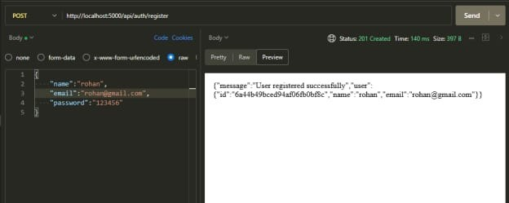
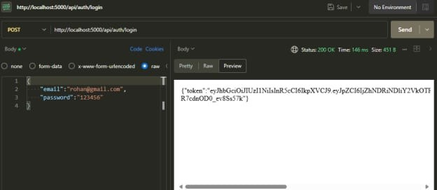
- Test create
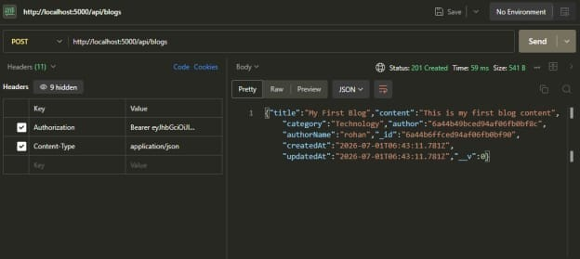
and fetch blog operations.
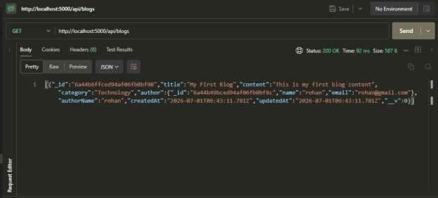
- Test AI blog generation.
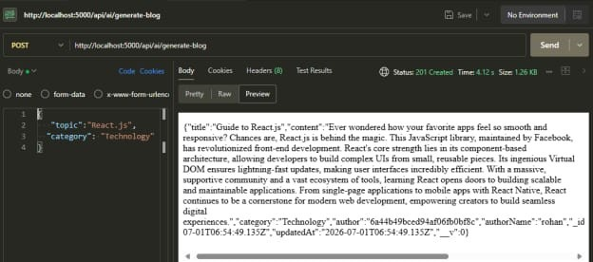
- Test blog summarization.
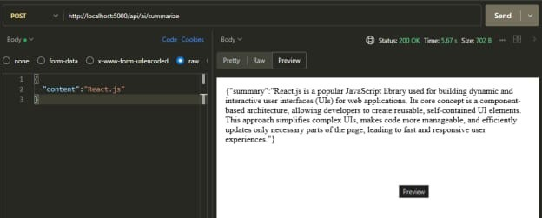
- Verify response status, JSON data and error messages.

5. Validation of Results
- Check successful responses.
- Check invalid input handling.
- Check protected routes with authentication.
- Verify that unauthorized roles cannot access restricted operations.
- Confirm that database changes are reflected correctly.
6. Expected Outcome
AI features are connected to the backend and the major API workflows are verified through testing.

7. Conclusion
This phase confirms that the backend, database and AI services work together through the defined API endpoints.

